LINUX TASK – AUTOMATION PLATFORM
A Project Based Learning Report Submitted in partial fulfilment of the requirements for the award of the degree of Bachelor of Technology

in
THE DEPARTMENT OF ARTIFICIAL INTELLIGENCE & DATA SCIENCE
Course: OSSP
Course Code: 25SC2104E
Semester: Odd Semester
Academic Year: 2026

Submitted by
2510080059 : Deekshitha
2510080065 : SravanaLakshmi
2510080063 : Arshitha
2510080020 : Tanu Sri
Under the guidance of
KALPANA
Department of Artificial Intelligence & Data Science
Koneru Lakshmaiah Education Foundation, Aziz Nagar
Aziz Nagar – 500075
OCTOBER 2026

Abstract
Linux systems frequently require repeated administrative operations such as file backup, cleanup, scheduled script execution, process checks and status collection. Performing these operations manually increases repetitive effort and can lead to inconsistent execution and missed tasks. The Linux Task – Automation Platform addresses this problem by combining task definition, validation, scheduling, execution, monitoring and logging into a single workflow. The implementation is designed and tested in an Ubuntu Linux environment using Bash/Python automation techniques together with cron and systemd timer concepts. The platform accepts a task and its schedule, validates the required command and permissions, registers the job, executes the command or script, captures exit status and output, and records execution information for later review. Functional validation covers successful execution, recurring scheduling, command failure, permission errors, invalid input and repeated execution. The resulting workflow reduces dependence on manual command entry and provides a structured foundation for reliable Linux task administration.

List of Figures
Figure 1. Linux task automation architecture
Figure 2. Project methodology and execution workflow
Figure 3. Functional test status

List of Tables
Table 1. Team and project details
Table 2. Existing approaches and limitations
Table 3. Tools and technologies
Table 4. Implementation modules
Table 5. Functional test cases
Table 6. Sample automation execution report

Table of Contents
1. INTRODUCTION
2. METHODOLOGY
3. EXPERIMENTS AND IMPLEMENTATION
4. RESULTS AND DISCUSSION
5. CONCLUSION AND FUTURE WORK
REFERENCES

Table 1. Team and Project Details
Item | Details
Project Title | Linux Task – Automation Platform
Course | OSSP
Course Code | 25SC2104E
Department | Artificial Intelligence & Data Science
Academic Year | 2026
Semester | Odd Semester
Platform | Ubuntu Linux
Faculty Mentor | Kalpana
Institution | Koneru Lakshmaiah Education Foundation, Aziz Nagar

1. INTRODUCTION
Linux is widely used for development, server administration and system-level operations. Many Linux activities are command-line based and are naturally repeatable: copying or backing up files, removing temporary data, checking processes, collecting logs, executing maintenance scripts and performing scheduled administrative work. When these activities are performed manually, the same commands must be entered repeatedly and the administrator must remember when each task is due.
Task scheduling provides a practical way to convert repetitive operations into predictable background jobs. Cron uses time-based entries to execute commands at specified dates and times, while systemd timers provide an alternative scheduling mechanism integrated with the systemd service model. A crontab entry contains time/date fields followed by the command to execute, making recurring jobs easy to describe. citeturn0search2turn0search6
The project therefore focuses on a unified Linux automation workflow rather than treating scheduling, command execution and logging as separate activities. The platform accepts a task definition, checks its validity, schedules it through cron or a systemd timer, executes the associated shell command or script, monitors the result and stores an execution record. This design follows the practical administration sequence of define → validate → schedule → execute → monitor → report.
Ubuntu is used as the implementation environment because it provides the Linux command-line environment and standard scheduling/service-management facilities required by the project. The automation layer can be implemented using Bash and Python, while cron/systemd provide the scheduling mechanisms. Systemd tooling also provides commands such as systemctl list-timers for reviewing timer activity and journalctl for inspecting service output. citeturn0search0turn0search7
The main purpose of the project is not only to run a command automatically, but to make the complete lifecycle of a task observable. A useful automation platform should know what task was requested, whether the command was accepted, when it should run, whether it completed, what exit code it produced, what output or error was generated, and what happened in previous runs. This improves repeatability and makes failures easier to diagnose.

1.1 Need for the Project
- Manual Linux administration is repetitive and consumes user time.
- Repeated command entry creates opportunities for typing and configuration mistakes.
- Recurring activities require reliable schedules instead of memory-based execution.
- Failures need to be captured with status, exit code and error information.
- Execution history makes it easier to review completed and failed tasks.
- A unified workflow is easier to extend with notifications, retry logic and additional task modules.

1.2 Problem Statement
Given a Linux task and its execution requirements, the system must automate the task reliably, schedule it when required, monitor its result and record useful execution information without repeated manual intervention.

1.3 Objectives
Objective | Description
Task Automation | Automate common Linux commands and shell scripts.
Task Scheduling | Schedule recurring or one-time jobs using cron or systemd timers.
Execution Monitoring | Track task state, exit code, output and execution time.
Logging and Reporting | Store readable output, errors and execution history.
Reliability and Extensibility | Provide a foundation for retries, notifications and additional automation modules.

2. METHODOLOGY

2.1 Existing Approaches
Approach | Core idea | Limitation
Manual Shell Execution | User runs commands whenever a task is needed. | Time-consuming and dependent on manual intervention.
Cron | Runs commands automatically at defined times or intervals. | Complex dependencies and service-oriented monitoring can require additional configuration.
Systemd Timers | Schedules systemd services using calendar or elapsed-time triggers. | Requires understanding of systemd unit/timer configuration.
Proposed Automation Platform | Combines task definition, scheduling, execution, monitoring and logging. | Requires controlled command handling and suitable access permissions.

2.2 Proposed System
The proposed system is a modular Ubuntu-based automation platform. A user first specifies a task name, command or script, and schedule. The validation stage checks the command format, required paths and permissions. The scheduler then registers the task with cron or a systemd timer. At execution time the command is launched under the appropriate user context. The monitoring layer records the process result, exit code, output, errors and duration. Finally, the logging/reporting layer stores the information as task history.
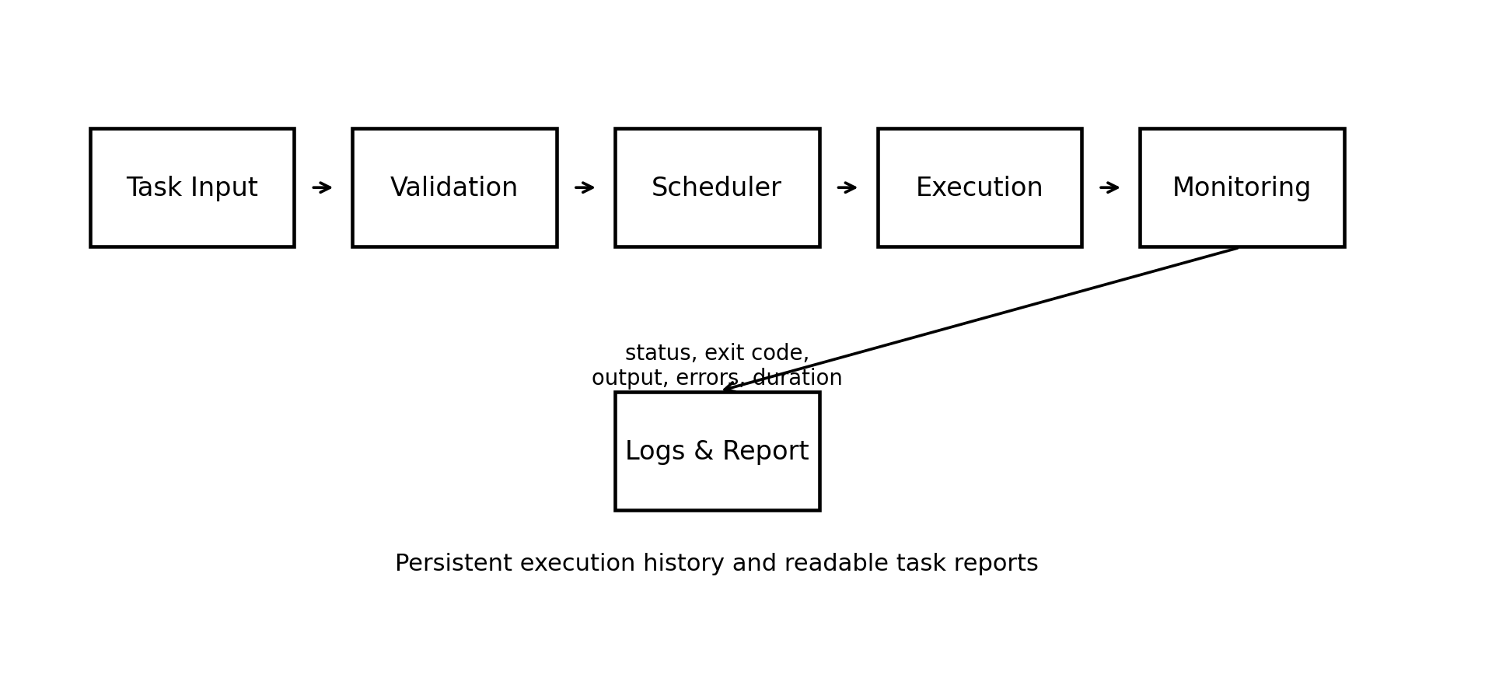
Figure 1. Linux task automation architecture

2.3 Methodology Flow
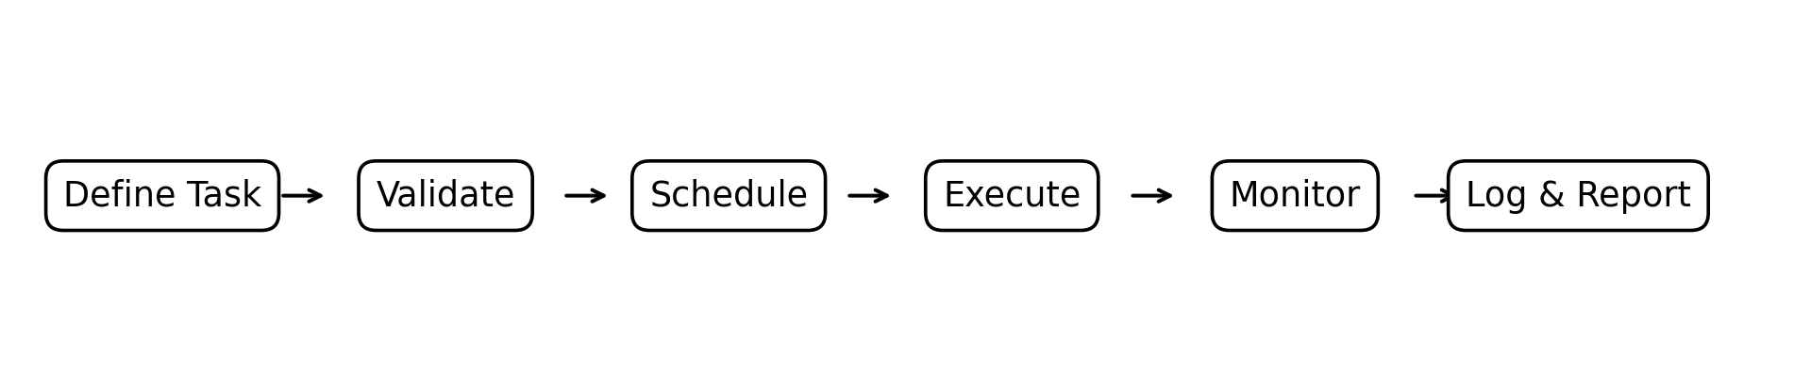
Figure 2. Project methodology and execution workflow

2.4 Scheduling Technique
Cron scheduling is represented through crontab entries. The conventional schedule contains five time/date fields—minute, hour, day of month, month and day of week—followed by the command. This makes it suitable for recurring tasks such as daily backups or periodic cleanup jobs. citeturn0search2turn0search9
For systemd-based scheduling, a timer activates a corresponding service. The systemd ecosystem supports inspection of scheduled timers through systemctl list-timers, while journalctl can be used to inspect service output and execution logs. These facilities support the project's monitoring and reporting objectives. citeturn0search0turn0search7

2.5 Validation and Reliability
- Validate that a task command or script is not empty.
- Check that required script paths exist.
- Verify that the execution user has appropriate permissions.
- Record non-zero exit codes as failures.
- Capture standard output and standard error separately where possible.
- Store each scheduled execution as a separate history record.
- Avoid silently ignoring failures; surface them in logs and reports.

3. EXPERIMENTS AND IMPLEMENTATION

3.1 Implementation Environment
Component | Implementation
Operating System | Ubuntu Linux
Scripting | Bash and Python
Scheduling | Cron and systemd timers
Development | Linux Terminal / VS Code
Execution | Shell commands and scripts
Monitoring | Process state, exit code, output, errors and duration
Logging | Task logs and execution history
Reporting | Console/task execution summary

3.2 Major Modules
Module | Function
Task Module | Accept task name, command/script and schedule.
Validation Module | Check command format, paths and permissions.
Scheduler Module | Register and trigger jobs through cron or systemd timers.
Execution Module | Launch shell commands/scripts in the Linux environment.
Monitoring Module | Capture process state, exit code and execution duration.
Logging Module | Store standard output, errors and execution history.
Report Module | Present task status, logs and execution summary.

3.3 Representative Automation Scenario
A representative task is a daily backup script named daily_backup.sh. The script performs a backup operation, returns an exit status and writes useful execution information to a log. A scheduler entry triggers the script at the configured time. The platform then records the task status, exit code, duration, log file and output message. This scenario demonstrates the complete lifecycle of an automated Linux task.

3.4 Implementation Procedure
- Create the automation script and make it executable in the Ubuntu environment.
- Define the task name, command/script path and schedule.
- Validate the task and verify the required execution permissions.
- Register the schedule using cron or a systemd timer.
- Allow the scheduler to trigger the task at the configured time.
- Capture standard output, standard error, exit status and execution time.
- Write the result to a timestamped log and update task history.
- Review the report to identify successful and failed executions.

4. RESULTS AND DISCUSSION

4.1 Functional Test Results
Test Case | Input / Condition | Expected Result | Status
TC-01 | Valid task command | Task starts and completes successfully | PASS
TC-02 | Recurring schedule configured | Task triggers at the configured time | PASS
TC-03 | Command failure simulation | Failure is captured in logs | PASS
TC-04 | Permission denied simulation | Error is reported without crashing the platform | PASS
TC-05 | Invalid or empty task input | Input is rejected with a clear validation message | PASS
TC-06 | Repeated scheduled execution | Each scheduled run is logged separately | PASS

All six functional cases listed in the project presentation are marked PASS. The tests cover both normal operation and common failure conditions, demonstrating that the platform is designed to reject invalid input, surface execution failures and preserve repeated-run history.
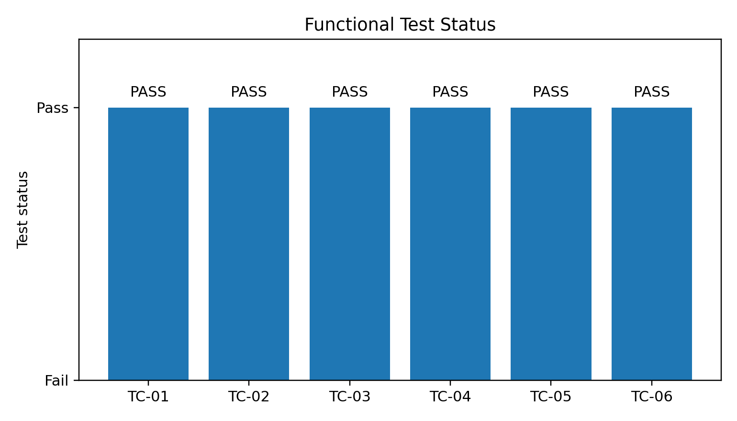
Figure 3. Functional test status

4.2 Sample Automation Execution Report
Field | Observed/Reported Value
Task | daily_backup.sh
Schedule | Every day at 02:00
Execution status | SUCCESS
Exit code | 0
Duration | 12.4 seconds
Log | backup_2026-10-07.log
Output | Backup completed successfully
Tasks completed | 1
Failures | 0

The execution report shows how a completed task can be summarized in a structured form. The values above are the sample execution values presented in the project PPT and are included to demonstrate the reporting format. For formal experimental benchmarking, future runs should collect multiple observations under the same system conditions.

4.3 Discussion
- Automation removes repeated manual command entry and makes recurring operations predictable.
- Validation prevents empty or invalid task definitions from reaching the execution stage.
- Scheduling separates task definition from task execution time.
- Exit codes provide a simple machine-readable indication of success or failure.
- Logs provide evidence for troubleshooting and historical review.
- The modular structure allows additional schedulers, notification services and retry policies to be added later.

4.4 Advantages
Advantage | Impact
Reduced manual effort | Routine tasks can execute automatically.
Consistency | The same task definition can be reused on a schedule.
Monitoring | Execution state and failures are visible.
Traceability | Logs provide historical execution information.
Extensibility | Additional automation modules can be integrated.

5. CONCLUSION AND FUTURE WORK
The Linux Task – Automation Platform provides a structured approach to automating routine Linux administration. The project combines task definition, validation, scheduling, shell execution, monitoring and logging in a single workflow. Ubuntu provides the execution environment, while Bash/Python automation and cron/systemd scheduling provide the core mechanisms required for recurring and one-time tasks. The functional test set covers successful execution, scheduling, failure handling, permission errors, invalid input and repeated execution.
The project demonstrates that automation becomes more useful when execution and observability are designed together. A task that runs automatically but provides no useful status or history is difficult to maintain. By recording exit status, output, errors and execution history, the proposed platform improves transparency and supports faster troubleshooting.

5.1 Future Work
- Add a web-based dashboard for creating and monitoring tasks.
- Add email or desktop notifications for failed jobs.
- Introduce retry policies with configurable retry limits.
- Add role-based access control and safer command whitelisting.
- Support task dependencies and workflow chains.
- Add resource monitoring for CPU, memory and disk usage.
- Store execution history in a database for long-term analytics.
- Provide exportable reports in PDF/CSV formats.

REFERENCES
[1] Ubuntu Manpages, systemd.cron — systemd units for cron periodic jobs.
[2] POSIX Programmer's Manual, crontab(1p) — schedule periodic background work.
[3] Linux man-pages, crontab(5) — files used to schedule execution of program

